CS 340 README Template

About the Project/Project Title
The Grazioso Salvare Dashboard project is a Python-based web application designed to interface with a MongoDB database containing animal shelter data from the Austin Animal Center (AAC). This dashboard builds on a previously developed CRUD module, providing users with an interactive and user-friendly interface for querying and visualizing animal data.

Built-in filter options allow users to filter and sort data based on criteria related to specific rescue scenarios. It includes a responsive data table, a geolocation map, and a data visualization pie chart.

Motivation
This tool supports Grazioso Salvare’s mission of identifying suitable dogs for specialized rescue training. By providing built-in filter options tailored directly to the requirements for specialized rescue training, users can visualize and traverse large datasets.

This tool acts as a force multiplier by streamlining data analysis, allowing personnel to focus more resources on training and care rather than manual data processing.

Getting Started
The layers of this module include:
- MongoDB database
- Python backend using a CRUD module (controller)
- Dash-based web application (view/controller)

MongoDB was selected for its flexibility in handling semi-structured data. It is suitable for handling datasets such as animal shelter data. It’s JSON-like format seamlessly integrates with Python dictionaries.

Dash is used to create an interactive web dashboard that communicates with MongoDB through the Python CRUD module.

Installation
Tools Required:
- Python 3.x // Simple and ideal for backend development
- MongoDB
- PyMongo library // The official driver for Python in MongoDB.
- Jupyter Notebook // Suitable for testing code functionality.
- Dash / Plotly // Selected to build the interactive dashboard and data visualizations.

Install the required library:
console
pip install pymongo dash plotly jupyter-dash dash-leaflet

To get a local copy up and running, follow these simple example steps:
- Install and run MongoDB locally
- Load the AAC dataset into a MongoDB database
- Create a user with authentication credentials (currently hard-coded)
- Update the connection variables in the CRUD module
- Ensure the dashboard notebook and CRUD module are in the same working directory
- Run the dashboard notebook

Development / Challenges
- Developed a MongoDB database using AAC dataset
  - Understanding MongoDB queries using operators such as $regex, $gte, and $lte was a new concept and initially challenging.
- Created a Python CRUD module for database interaction
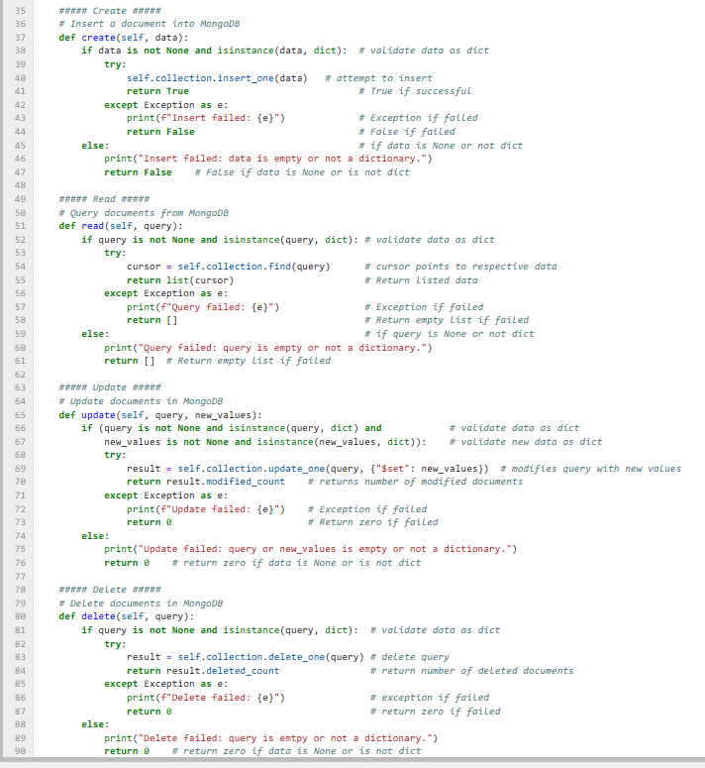

- Built an initial data table displaying unfiltered records
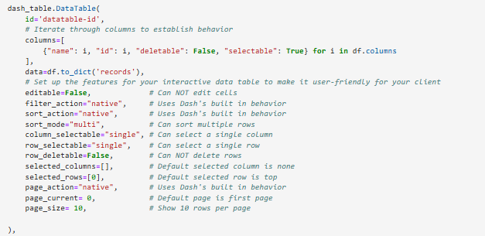
- Integrated geolocation map
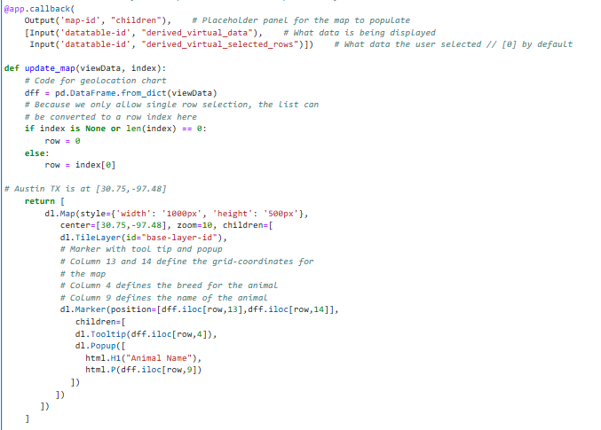

- Implemented filtering logic
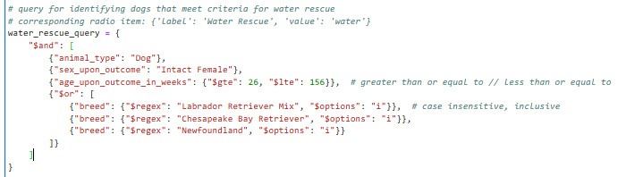
- Created interactive radio buttons for filter selections
  - Connecting components such as the filters and charts required an understanding of Dash callbacks and a lot of research/experimentation.
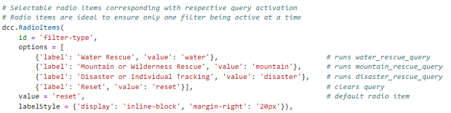
- Added data visualization pie chart
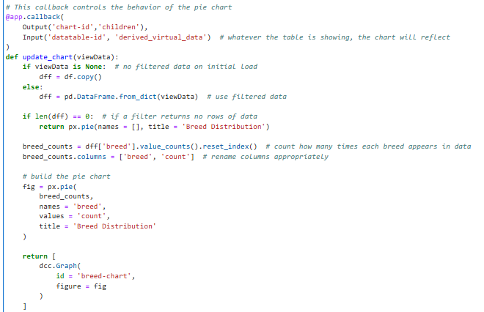
- Added Brand Logo
  - Displaying the Grazioso Salvare logo was challenging and required troubleshooting file path issues within Jupyter Notebook. This issue was resolved by using base64 to encode the image and embed it directly into the dashboard. This bypassed the need to rely on file pathing.
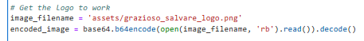

Usage
The dashboard allows users to interact with the AAC dataset through the following features:

- Interactive Filters
  - Users can one of the four filter options:
    - Water Rescue
    - Mountain or Wilderness Rescue
    - Disaster or Individual Tracking
    - Reset (removes all filters)
  - Each filter applies predefined criteria based on:
    - Breed
    - Sex
    - Age range
- Dynamic Data Table
  - The data table updates automatically based on the selected filter and includes:
    - Sorting
    - Filtering
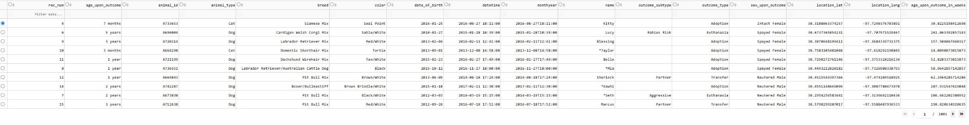
    - Page number
    - Row selection
- Geolocation Map
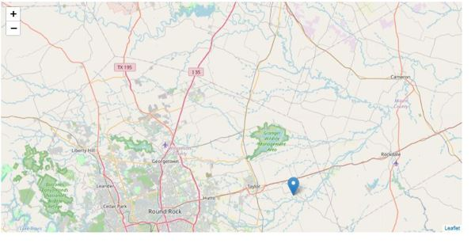
  - The map displays the location of the selected animal

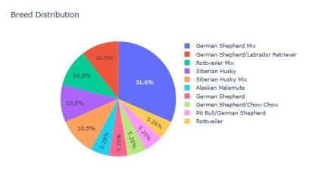
- Data Visualization Pie Chart
  - The pie chart displays the distribution of dog breeds, reflecting the selected filter appropriately

Testing
The dashboard was tested by running the application and verifying that:
- Each filter correctly updated the data table
- The map reflects the location of the dog that is selected and updates appropriately
- The pie chart reflects the data and updates when data is filtered
- Reset removes all filters and returns all data

Demonstration
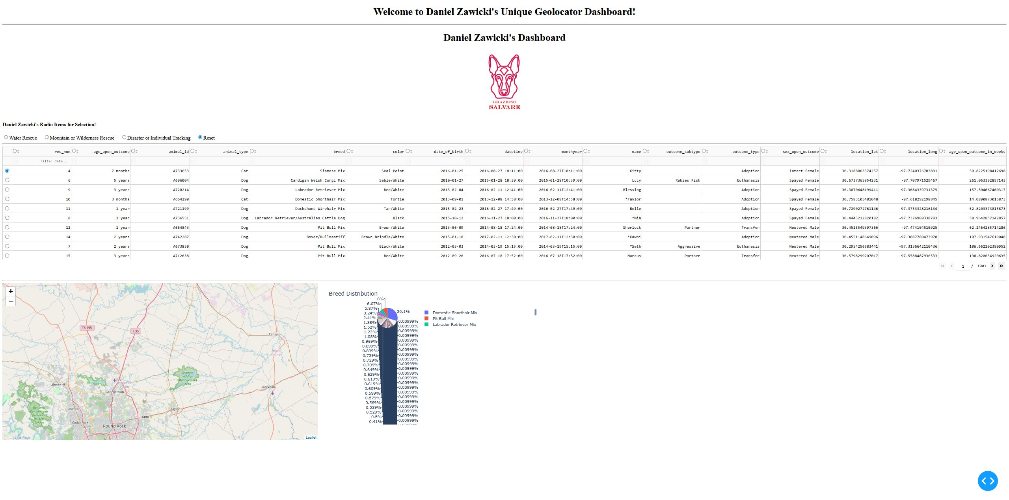
- Initial Launch (Reset)
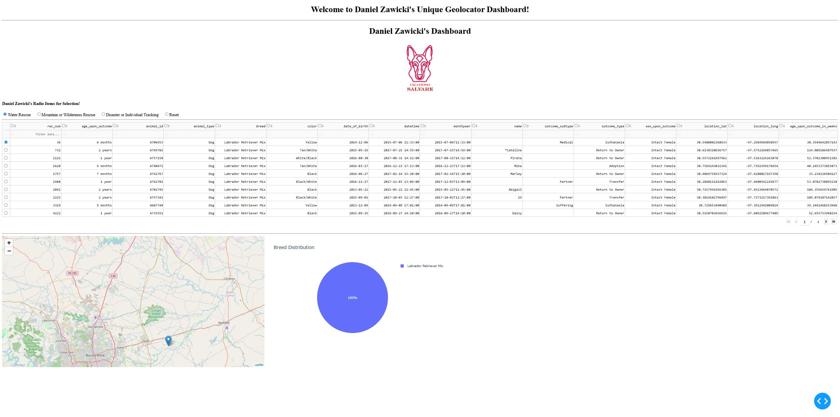
- Water Rescue Filter

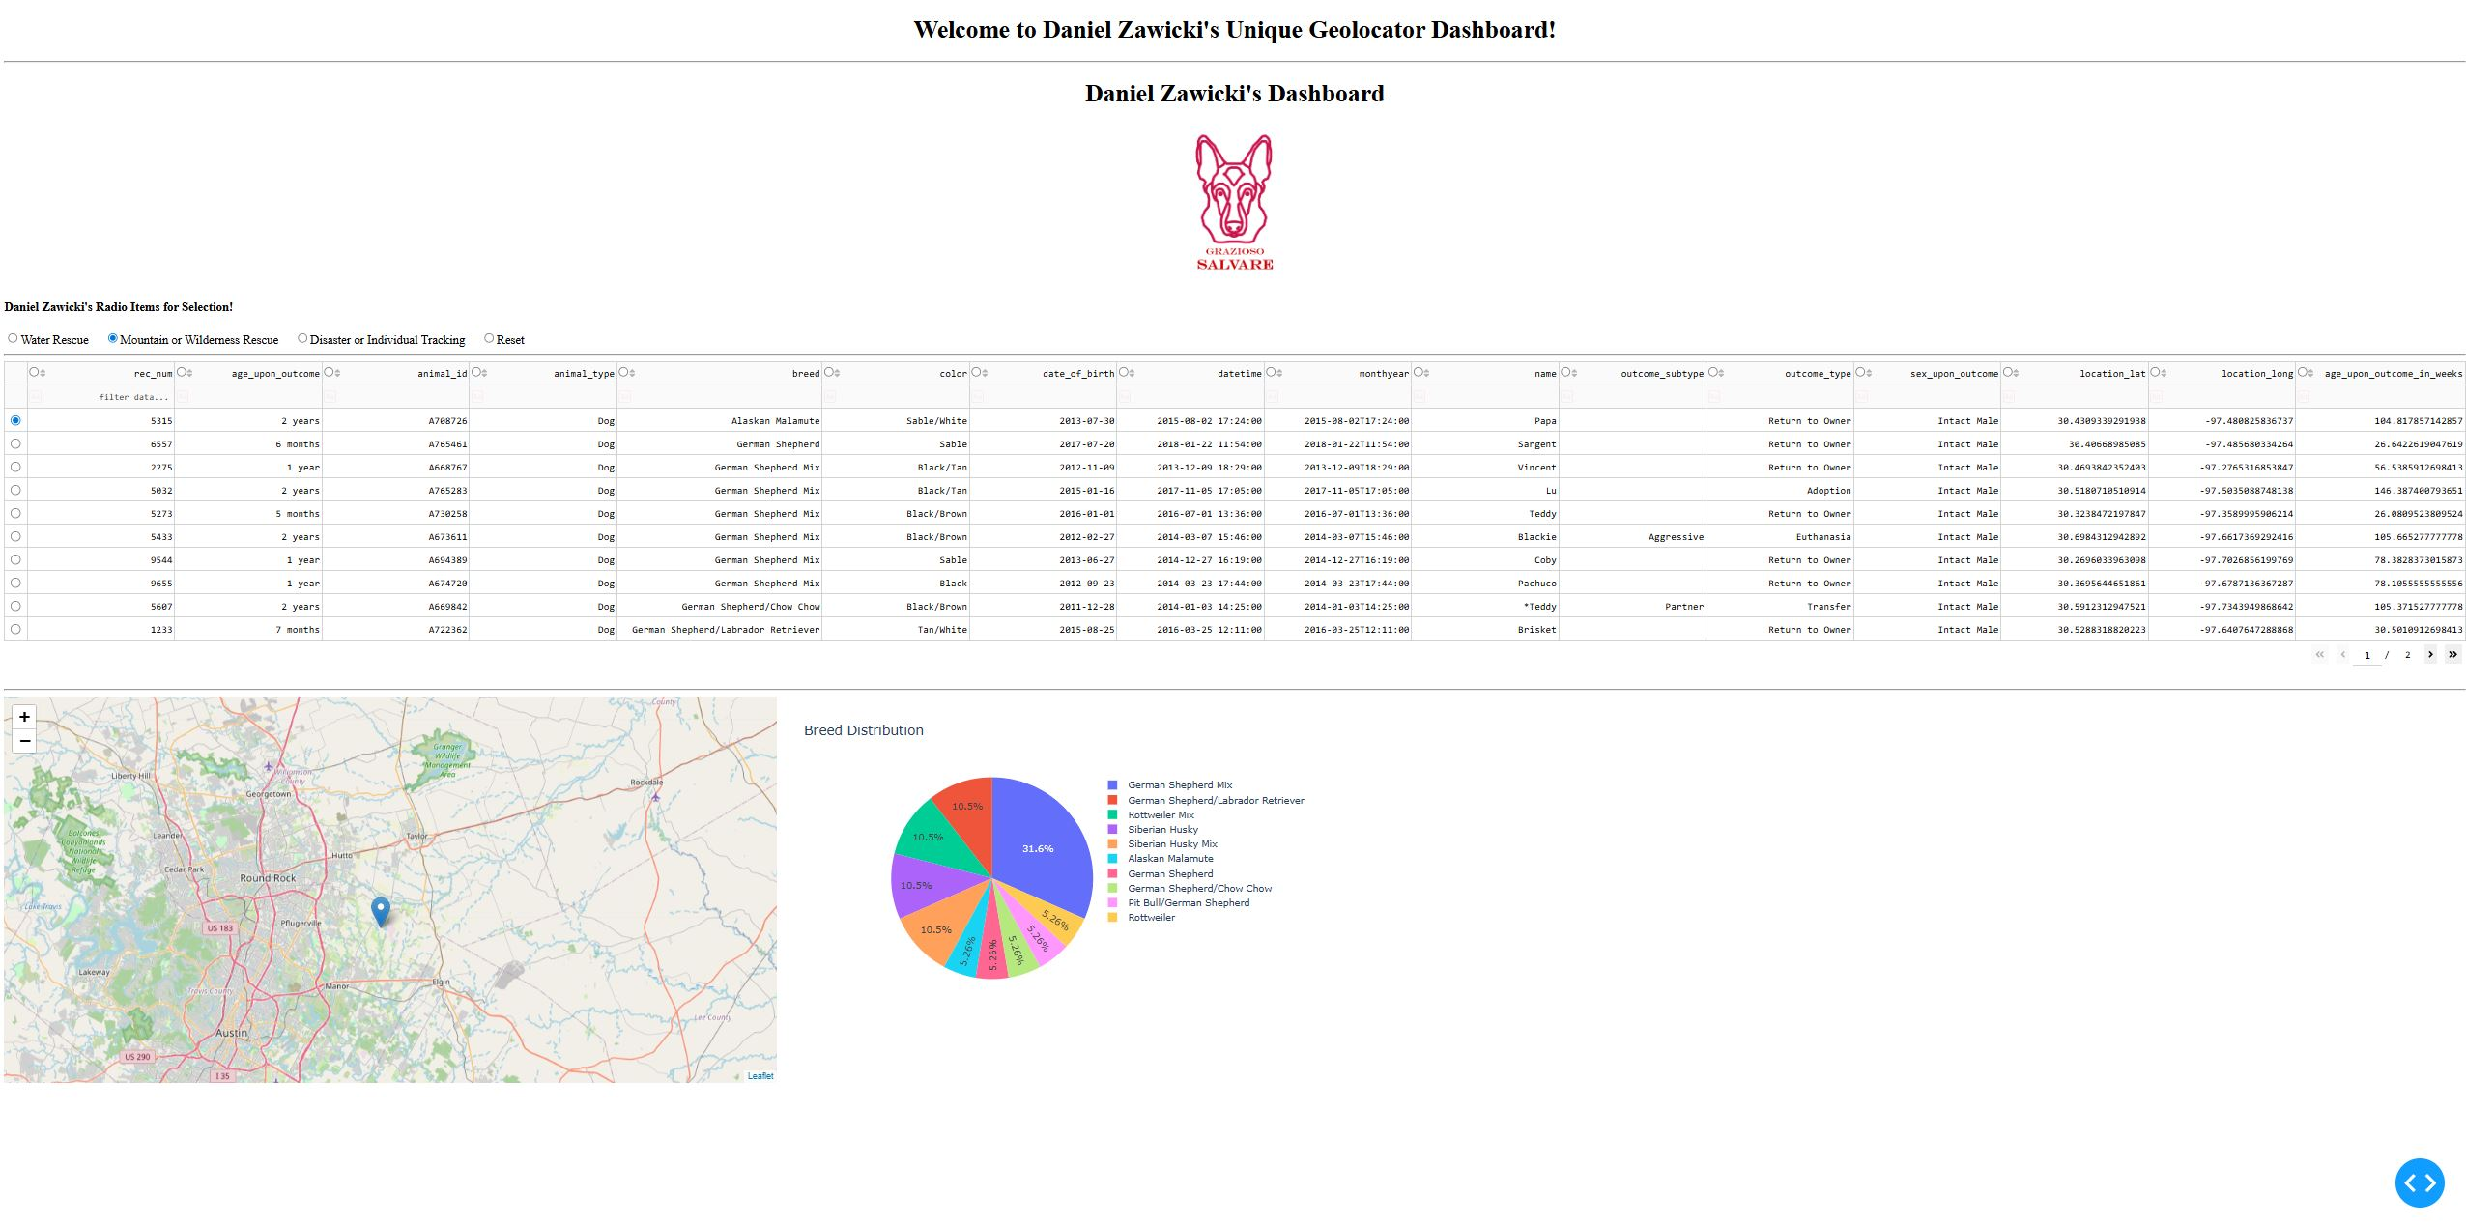
- Mountain or Wilderness Rescue

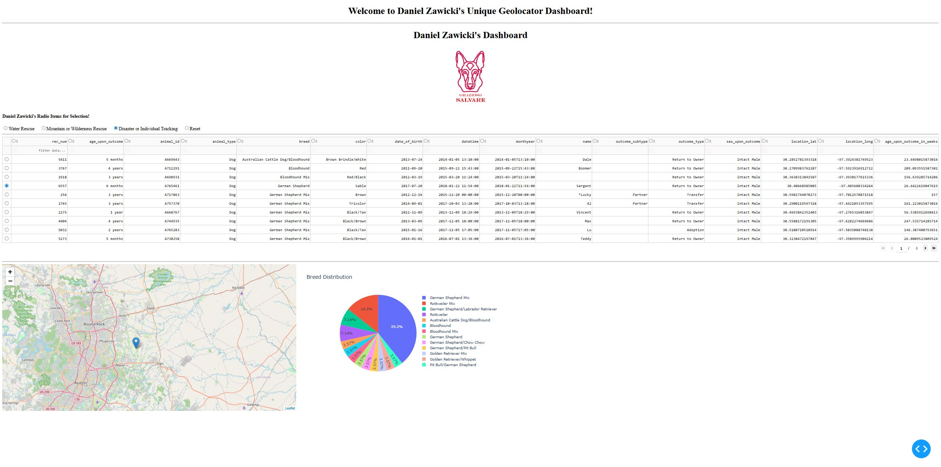
- Disaster or Individual Tracking

Contact
Daniel Zawicki

